Dear ‘Cooking With CQL’ team. We are reaching out to see if you can help us solve a CQL-related issue for one of our hospital harm patient safety measures currently under development.

The measure is an episode of care based measure with the IPP / Denominator defined as:

All inpatient encounters discharged during the measurement period for patients 18 years or older at the start of the encounter.

An encounter is considered an inpatient admission, including time spent in the emergency department or in observation status when the patients are ultimately admitted to inpatient status.

We would like assistance with expressing in CQL that the *qualifying encounter length of stay must be at least 48 hours.* This could be applied as either:

1. A denominator exclusion, where we would exclude encounters (including time spent in the emergency dept or in observation prior to admission) with length of stay < 48 hours

Or:

1. A condition of the qualifying encounter where the length of stay (including time spent in the emergency dept or in observation prior to admission) must be > = 48 hours.

Attempts at expressing it as a condition of the qualifying encounter, #2 above, included revising our existing *Qualifying Encounter* definition (which defines our IPP and Denominator):

["Encounter, Performed": "Encounter Inpatient"] InpatientEncounter

with ["Patient Characteristic Birthdate": "Birth date"] BirthDate

such that InpatientEncounter.relevantPeriod ends during "Measurement Period"

and Global."CalendarAgeInYearsAt" ( BirthDate.birthDatetime, start of Global."HospitalizationWithObservation" ( InpatientEncounter ) ) >= 18

To:

["Encounter, Performed": "Encounter Inpatient"] InpatientEncounter

with ["Patient Characteristic Birthdate": "Birth date"] BirthDate

such that InpatientEncounter.relevantPeriod ends during "Measurement Period"

and Global."CalendarAgeInYearsAt" ( BirthDate.birthDatetime, start of Global."HospitalizationWithObservation" ( InpatientEncounter ) ) >= 18

and Global." HospitalizationWithObservationLengthofStay" ( InpatientEncounter ) >= 2

This did not meet our needs because using the ‘day’ interval does not always equate to 48 hours, as seen in this scenario created in Bonnie:

1. Patient encounter starts 9/20 at 8:00am in ED:

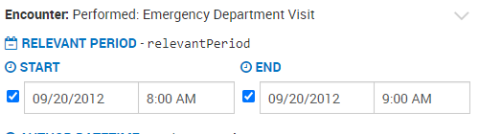

2. Patient transfers to inpatient:

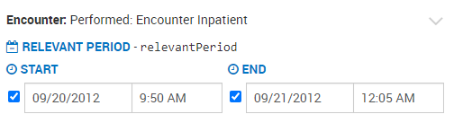

3. Patient encounter ends 9/21 at 12:05am. Total length of stay duration in hours = 16 hours, 5 minutes.

Undesired test case outcome: The encounter was still considered >= 2 ‘days’ even though the duration is less 48 hours. It is critical that the duration of the encounter must be at least 48 hours.

Other CQL revisions were tried and tested, including expressing CQL to apply an exclusion:

"Qualifying Encounters" QualifyingEncounter

where duration in hours of QualifyingEncounter.relevantPeriod < 48

This also resulted in an undesired test case outcome, since the duration begins calculating at the inpatient admission only, not at any previous time in the ED and or Observation prior to admission.

Using the “Encounter, Performed” lengthOfStay attribute – such as seen in the following expression - is also not desirable, as we want the duration to be calculated based on the relevant period.

* + **Encounters With Length of Stay Less Than 48 hours**
    - * from
      * "Qualifying Encounters" QualifyingEncounter
      * where QualifyingEncounter.lengthOfStay < 48 hours
      * return QualifyingEncounter

So we are turning to you to help us with expressing in CQL that the *qualifying encounter length of stay must be at least 48 hours* as either an exclusion or condition of the encounter? Would a function that works similar to the “HospitalizationWithObservationLengthofStay" global function but instead determines LOS based on hours instead of days be a possibility?

We have provided the definition of our Qualifying Encounter (IPP / Denominator), but please let us know if there are other logic sections you’d like to see.